**Software Development 4**

**Sample CA2**

**Duration: 1 hour 45 mins**

You are required to develop a system for a car salesman called Peter who sells cars imported from Japan.

The data on the cars is provided below. Create a folder in your IntelliJ project called **files** and then create a file called **cars.txt** and copy the following text into the file.

Ford,Ford Focus,1000,700,o,2400

BMW,3Series,7000,750,o,12000

BMW,5Series,17000,700,o,30000

Honda,Honda Jazz,5000,550,o,8000

Honda,Honda Stream,5250,400,o,7800

Mitsubishi,Mitsubishi Outlander,21000,750,o,30000

Nissan,Nissan Micra,7000,400,t,10000

Nissan,Nissan Micra,4000,300,t,6000

Mitsubishi,Mitsubishi Colt,10895,900,t,14000

In the file there are 6 pieces of data on each car and each piece of data is separated by a comma. The following table shows what each value in the file represents:

|  |  |  |  |  |  |
| --- | --- | --- | --- | --- | --- |
| Make | Model | Purchase price | Shipping Cost | Port | Selling Price |

Create a class called Car.java.

**Car Class**

This class has 6 member variables:

* Make of the car (String)
* Model of the car (String)
* Purchase price (double)
* Shipping cost (double)
* Port (char)
* Selling price (double)

The purchase price is the price that Peter paid for the car in Japan

The shipping cost is the cost of shipping the car from Japan to Ireland

The cars that Peter bought are shipped from either of two ports in Japan – Osaka or Tokyo. These are represented in the file as the character ‘o’ and ‘t’ and are represented in the Car class using the char data type.

Create a constructor to initialise all members using a parameter list

Create suitable getter & setter methods. The getter method for the port name should return a string indicating the name of the port. For example, if the port is o then return “Osaka” else return “Tokyo”

**CarDB Class**

This class has three member variables:

* an arraylist that is used to store a collection of Car objects
* an array of type double which will be used to hold the total cost of each car – this array will be initialised and populated in a method later

1. **addCar() method**

Write this method which takes 6 parameters, creates a Car object and adds it to the arraylist.

1. **displayList() method**

Write this method to display car details formatted as follows. Note the full names are displayed for each of the ports using the getter method you wrote earlier.

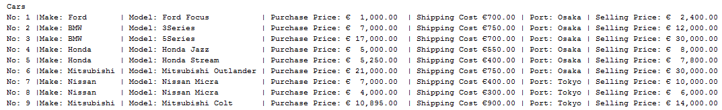

**You should test this method before you write any new methods. Write the test class using the details provided on page 4**

1. **calcMostExpensive() method**

Write this method to calculate and print details of the most expensive car(s). This method when called should display the model of car and the selling price. Note that there are two cars with the highest selling price – both should be displayed.



**You should test this method before you write any new methods.**

1. **calcImportDuty() method**

For Peter to import cars to Ireland he must pay import duty and other charges as shown below:

* For Osaka the port duty rate is 10% and the unloading fee is €100
* For Tokyo the port duty rate is 15% and the unloading fee is €150
* The VAT rate is 23%
* The broker fee is €120

Write this method to calculate & print the following information formatted as shown:

1. The model of each car
2. The cost of each car (purchase price + shipping cost)
3. The import cost which you will need to calculate (details provided below)
4. The total cost (the sum of cost and import cost)

These details should be formatted as shown in the sample output:

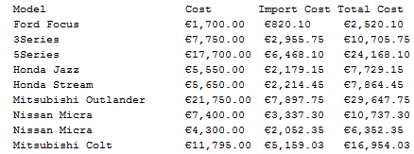

Inside this method, you should initialise the array of type double defined earlier. When you write the code to calculate the total cost of the cars you should store the total cost for each car in this array.

The total cost to import a car is calculated as follows:

* The port duty is the Purchase price + shipping cost * the port duty rate
* The VAT is 23% of the Purchase price + shipping cost+ port duty
* The import cost is the port duty + VAT + Unloading Fee + Broker Fee
* The total cost to import a car is the purchase price + shipping cost + import cost

Example calculation for the 1st car in the text file

* Purchase Price = 1000
* Shipping cost = 700
* Port duty = (1000+700)*.1 (.1 is the rate for Osaka) = 170
* VAT = .23*(1000+700+170) = 430.1
* Total import cost = 170+430.1+100+120 = 820.10
* Total Cost of a car = 1000+700+820.10 = 2520.10

**Test Class**

Write the test class to do the following:

Read the data in from the text file and use this data to create Car objects and add them to the array in the CarDB class. Include relevant exception handling code.

Write code to display the following menu to the user:

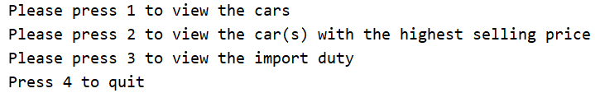

When the user presses 1 the displayList() method should be called

When the user presses 2 the calcMostExpensive() method should be called

When the user presses 3 the calcImportDuty() method should be called

When the user presses 4 the program exits